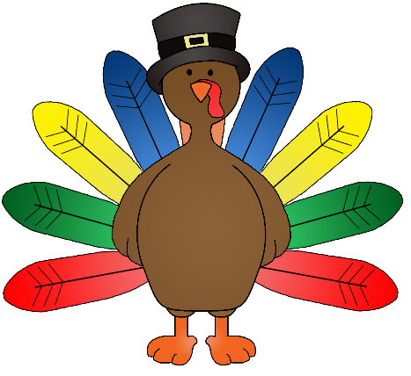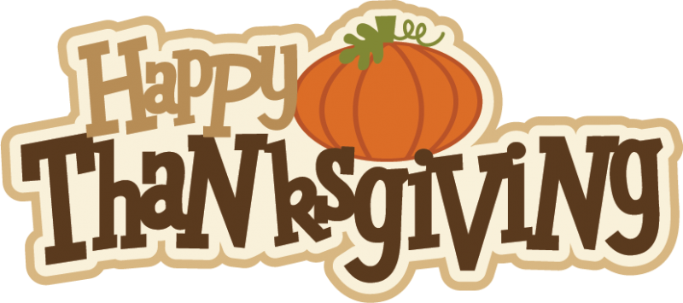
This Photo by Unknown Author is licensed under CC BY-NC-ND
This Photo by Unknown Author is licensed under CC BY-NC-ND

Ms. Wood’s Pre-K Lesson Plans
November 18-22, 2019
Theme of the Week: Happy Thanksgiving!
Time Mon. Tues. Wed. Thurs. Fri.

Daily Grade My Duty Early Level Day Out Mtg. I will be
@ Nap gone for
Varsity Cheer
Regional / All State Tryouts
8:40-9:35 Free Play in Developmental Centers Potty as needed (HSPD 3.3) … incorporating in Journals (C3 LA 2.3, 2.5, 4.1, 4.2, 5.1, 6.2)

Sensory Bin – Closed at Free Play but Open during Work Stations
Home & Living / Dramatic Play -- in the Kitchen Area with tablecloth, basket, family pictures, dishes, puzzle / play food, placemats, cookbooks, couch with pillows and quilt, dolls, blanket, baby bed, stuffed dog, cat, and fish for pets, pretend pet food bowls, plus telephones and class phone book.
Writing Center – scrap, recycled paper, crayons, word banks and flip books, and alphabet chart plus writing / tracing the room apple theme words.
Art / Painting at Easle -- open for art and creativity.
Art / Fine Motor Skills: Free drawing on scrap, recycled papers, and coloring sheets plus some line tracing, name tracing, and supervised scissor skills.
Math / Fine Motor Skills: Manipulatives out for free play and exploration.
Teacher Table – open for beginning assessments of students and helping them with writing their names!
Literacy / Fine Motor Skills: Name Tracing, Letter Practice / Tracing, manipulative letters with pegs plus building their name bags practice.
“BIG” Computer (Hatch – provided by Head Start): using touch screen technology and working on Starfall. They have to follow the rules and stay on Starfall or they will lose the privilege to have this station to work and play at.
i-pads – using very familiar technology to most of the students where they can play on PBS Kids, Starfall, tracing letter apps, sign language app, and a math / shape / patterning app, and a Disney jr. one, etc.
Library: enjoy thematic books (+ Big Books).
PLUS Classroom Produced Books: enjoy books we’ve put together in class
Science / Social Studies: Scales for Measuring and Houses and People plus adding wooden circles, pinecones, pine needles, acorns, leaves and students can explore them and use them with play doh center this week.
Listening: Closed.
Magnetic Station: Open for fun with magnets
Poem / Pocket Chart Station
Puzzles (Floor & Smaller Ones on Table): 3 small farming wooden puzzles
Blocks: red blocks with farm animals and people. RWSR
Morning Work: Name Tracing & Writing
C3 Skills: ATL S1.1, 1.3. 1.5, 1.6, 1.7, 1.8; CS 1.2, 1.3, 1.4, 1.5, 1.6;LA 1.2, 2.1, 2.5, 3.9; HSPD 2.1, 2.2; SPS 1.1, 1.2, 1.3, 1.4, 1.5, 1.6, 1.7, 1.8, 1.9, 1.10, 2.2
Objective: To participate freely in centers while being creative and learning to play well with others.
9:35-9:40 Clean Up
9:40-10:00 Community Carpet Time
Music & Movement -- ______________________________
Calendar
Mini Math Lesson – (within calendar time & songs & using cubes)
Weather
Flag Salutes & Patriotic Songs & Moment of Silence
Mini Literacy-Themed Lesson / Activity (Name of the Day) below

Mon.
Tue.
Wed.
Thurs.
Fri.

Learning Letter Go Letters Cheer Do You Know Alphabet Rap Do You Know
Sounds A-Z Cheer Your Alphabet? Color Words Rap Your Alphabet
5 Little Turkeys Number Words Rap 5 Little Turkeys Brown Color Song 5 Little Turkeys
Albuquerque T. 10 Little Indians Albuequerque T. Little Pilgrim Albuquerque T.
Do the Turkey Hop Thank You for Th. Turkey in the Straw Gobble Gobble Thank You for Th.
Calendar:
Environmental Word Wall: Mon / Wed / Fri
Flag Salutes with Patriotic Songs (Oklahoma & You’re A Grand Old Flag or This Land Is Your Land)

Name of the Day – (everyday but Wed) -- Draw someone’s popsickle stick out of the name cup.
- Have them tell you what their name is and count their number of letters altogether.
- Write down the number of letters in their name in number form, word form, tally marks, and ten frame.
- Tape their name letters up together to form a word / their name.
- Write their name and talk about how names begin with a capital letter.
- Use the chant: Hickory Dickory, Bumble Bee – Can You Say the (name, letter, sight word, number, etc.) with me? (say it in a normal voice, cheer it, whisper it, etc.)
- Say the child’s name and ask the class to listen for the number of syllables or parts they hear. Say it again and clap it out. Say it a third time and use your fingers and show them how you count the parts or syllables. Have them do it with you.
- Q#1 -- Ask the student how old they are – Then help them put their age into a sentence form and write it on your tablet on the easel. State that sentences begin with a capital letter and end with a punctuation mark / period. Show and tell them that you make spaghetti size spaces between the letters in a word and you use meatball spaces in between the words of a sentence.
- Q#2 -- Ask the student the last question, what is their favorite ______. Help them put their favorite ____ into a sentence form and write it on your tablet on the easel.
- Count the number of words in the sentence and look for any letters we are learning or sight words and circle or highlight them.
Other Activities: Boy & Girl Line Leaders of the Day flip to the next name in the pink and blue cards up by the calendar.

C3 Skills: ATL S1.1, 1.3. 1.5, 1.6, 1.7, 1.8; CS 1.1, 1.3, 1.5, 1.6, 1.7; LA 1.1, 1.2,2.1, 2.2, 2.3, 2.4, 2.5,3.4, 3.5, 3.6, 3.7, 3.8, 4.2, 5.1, 5.2, 6.1, 6.2, 6.3, 6.4, 7.1, 7.3, 9.1; SPS 1.7, 2.1; SS 1.2, 1.3, 1.5, 1.6, 2.1, 2.2
Objectives: Listen to others while in large and small groups. Identify the American flag as a national symbol of our country and understand the etiquette of its use. Identify the Oklahoma flag as a symbol of our state. Begin to develop an understanding of days of the week. Begin recognizing their own name and names of their peers. Start identifying the calendar as a tool to tell us the date.
Sing Oklahoma song and You’re a Grand Old Flag
10:00-10:05 Bathroom Break (HSPD 3.3)
10:05-10:40 Morning Recess (*if inclement weather: just played longer or more large group work.)
*** TUESDAY’s PE Special from 10:30-11 also MY DUTY DAY ***
Morning Recess
C3 SPS 1.1, 1.2, 1.5, 1.9, HSPD 1.1, 1.2, 1.3, 1.4, 1.5, 1.6, 3.1, 3.2, 3.4
Objective: Demonstrate increasing abilities to use the slide and swings. Lesson: Participate in free play outdoors.
10:40-10:45 Bathroom Break (HSPD 3.3)
10:45-10:55 Read Aloud / Class Discussion
C3 Skills: LA 1.1, 2.2, 2.3, 2.5, 3.1, 3.2, 3.3, 3.4, 3.5, 3.7, 4.1, 4.2, 5.1, 5.2, 6.4, 7.3, 8.1, 8.2, 8.3, 8.4, 8.6
Monday Over the River and Through the Woods

Tuesday Countdown to Thanksgiving

Objective: Listening to stories and showing understanding. Linking prior knowledge to a text.
Objective: Linking prior knowledge to a text. Listening to rhymes and showing understanding. Recognizing that print and pictures convey information. Tracking print from left to right and from top to bottom
Wednesday The Night Before Thanksgiving
Discussion:
Objective: Listening to stories and showing understanding. Linking prior knowledge to a text.

Thursday 10 Turkeys in the Road

Objective: Listening to stories and showing understanding. Linking prior knowledge to a text.

Friday Give Thanks Each Day
Objective: Listening to stories and showing understanding. Linking prior knowledge to a text.
Objective: Linking prior knowledge to a text. Listening to rhymes and showing understanding. Recognizing that print and pictures convey information. Tracking print from left to right and from top to bottom
10:55-11:00 Walk to Lunch
11:00-11:30 Lunch
11:30-noon Recess
C3 SPS 1.1, 1.2, 1.5, 1.9, HSPD 1.1, 1.2, 1.3, 1.4, 1.5, 1.6, 3.1, 3.2, 3.4
Objective: Demonstrate increasing abilities to use the slide and swings. Lesson: Participate in free play outdoors.
12:00-12:15 Bathroom Break / Calm Down & Cool Down on the Carpet (HSPD 3.3) / Smart Board Learning Songs (Social Skills, Manners, incorporate ………………..Mini Math/Literacy Lessons)

Mon. Tue. Wed. Thurs. Fri.

12:15 – 1:15 Work Stations / Math & Literacy Learning Centers
Literacy Centers C3 Skills: LA 1.1, 2.2, 2.3, 2.5, 3.1, 3.2, 3.3, 3.4, 3.5, 3.7, 4.1, 4.2, 5.1, 5.2, 6.4, 7.3, 8.1, 8.2, 8.3, 8.4, 8.6 SPS 1.7, 2.1 Math Centers C3 Skills: M 2.1, 2.2, 2.3, 2.5, 2.6, 3.1, 3.2, 4.2, 5.2, 5.3; HSPD 2.1, 2.2
Monday
Library 2 – Enjoy thematic unit books
Circle Table 2 – ABC’s – Write the Room Thanksgiving Words
Blocks 2 – play and create together w/ work station buddies
Shannon’s Table 4 – Owl Bag Art
Square Table 2 – Math – Circle the same sized stuff then play with the opposites puzzle
Home & Living 2 – pretend and play in Home and Living
Teacher’s Table 4 – Happy Thanksgiving Reader
i-pads or (TEE PEE) 2 – learning with technology or playing in tee pee

Tuesday
Library 2 – Enjoy thematic unit books
Circle Table 2 – ABC’s – Write the Room Thanksgiving Words
Blocks 2 – play and create together w/ work station buddies
Shannon’s Table 4 – Roll and Color Thanksgiving Dinner
Square Table 2 – Math – Circle the same sized stuff then play with the opposites puzzle
Home & Living 2 – pretend and play in Home and Living
Teacher’s Table 4 – Sound Out Words #1 paper
i-pads or (TEE PEE) 2 – learning with technology or playing in tee pee

Wednesday
No Time for Work Stations because it’s early out day.
Thursday
Library 2 – Enjoy thematic unit books
Circle Table 2 – ABC’s – Give Thanks for Thanksgiving – trace and color
Blocks 2 – play and create together w/ work station buddies
Shannon’s Table 4 – Scarecrow Bags
Square Table 2 – Math – Count cotton balls and put on matching number pies
Home & Living 2 – pretend and play in Home and Living
Teacher’s Table 4 – Sound out words #2 paper
i-pads or (TEE PEE) 2 – learning with technology or playing in tee pee

Friday
Library 2 – Enjoy thematic unit books
Circle Table 2 – ABC’s – Give Thanks for Thanksgiving – trace and color
Blocks 2 – play and create together w/ work station buddies
Shannon’s Table 4 – Play candyland game
Square Table 2 – Math – Count cotton balls and put on matching number pies
Home & Living 2 – pretend and play in Home and Living
Teacher’s Table 4 – Bang Game
i-pads or (TEE PEE) 2 – learning with technology or playing in tee pee

(Potty as needed (HSPD 3.3)
1:15-1:20 Clean Up
1:20-1:30 Name of the Day or Weekly Reader / Set up for Snack

Monday Write on / Wipe off boards
Tuesday Journals
Wednesday nothing
Thursday Write on / Wipe off Boards
Friday Journals OR Cosmic Yoga

1:30-1:40 Snack Time
1:40-2:40 Rest Time / Teacher’s Planning Time

2:40-2:45 Bathroom Break (HSPD 3.3) / Pack Up & Get Ready for Dismissal
3:00 Dismissal: Car Riders, Day Care Vans, Bus Riders

Full Videos:
- The Berenstain Bears Count Their Blessings – by Music Records 10 – 12 mins.
- A Charlie Brown’s Thanksgiving – full, by Old Memories, 25 mins.

